CivicConnect — PED v2.0: Architecture & Quality Drivers (Person 1 draft)
How to use this: each numbered section below is written to paste into PED v2.0 as a continuation of M1 (not a separate M2 report). Text in [square brackets] needs your team's input or verification. Nothing from M1 is deleted: changes go through the change log in Section 1.

1. Document control and M1 baseline review (PED v2.0)
1.1 Version history (append to the M1 table, keep the original rows)
Version | Date | Author | Changes
0.1 | 06 September | Armand | Work split and format (M1, retained)
0.8 | 08 September | Team | Each member integrates sections (M1, retained)
1.0 | 09 September | Team | Verified M1 baseline for submission (M1, retained)
1.1 | 09 September | Person 1 | M1 review findings logged as change requests CR-001 to CR-003 (Section 1.2)
2.0 | 10 September | Team | Architecture, Technology & Initial Design Baseline: ASRs, architecture decision, ADR-001 to ADR-004, RTM evolution, updated risks and forward considerations
1.2 M1 baseline review: findings requiring controlled change
Reviewing M1 against what architecture now needs surfaced three issues. They touch baselined content, so they are raised as change requests, not silently edited (the M2 brief requires the original baseline and reason for change to be preserved).
CR | M1 item | Issue | Proposed change | Reason
CR-001 | NFR-024 / AC-024 | Requirement says "at least 95-98% of requests" but the acceptance criterion says 95%. The range is ambiguous and cannot be tested. | Restate as: "at least 95% of regular operations return feedback within 3 seconds under the expected load [define load]." Original wording retained in the change log. | A testable target is needed to evaluate architecture against ASR-5.
CR-002 | FR-015 | "Overdue" is required in reporting but M1 defines no due date or overdue rule (SLA escalation is deferred in Section 3.3). | Add a clarification: a request is overdue when [rule, e.g. unresolved after N working days by category]. Escalation remains deferred. | Overdue status needs a data attribute (due date / threshold). This affects the data model (Person 2) and the Reporting module.
CR-003 | AC-0010 (FR-010) | Identifier typo; all others use three digits (AC-001 to AC-016). | Correct to AC-010. | Traceability integrity.
Scope is unchanged by CR-001 to CR-003. Approval: [three sign-offs, recorded in the PR].
1.3 Assumptions and constraints carried forward
The M1 constraints (scope, schedule, cost, quality, security) remain in force. Two are now architecturally active:
- Cost/resources: M1 requires free-tier limits to be recorded as an explicit assumption. Architecturally this means a single deployable unit on a single host is the default assumption, to be revisited with the technology and deployment evidence (Person 2).
- Security/POPIA: M1 requires personal information to be handled lawfully under POPIA (Republic of South Africa, 2013). This becomes ASR-1 below.

2. Architecture Significant Requirements (ASRs) and quality drivers
An ASR is a requirement that has a measurable effect on the architecture: if it changed, the structure of the system would have to change (Bass, Clements and Kazman, 2021). Not all 24 M1 requirements qualify. Five do.
2.1 Selected ASRs
ASR | Quality attribute (ISO/IEC, 2011) | Driven by (M1 evidence) | Measurable expectation | Architectural consequence
ASR-1 Controlled access to request data | Security: confidentiality, authenticity | NFR-017, NFR-018, NFR-019, FR-007; Security constraint; Management-vs-privacy conflict (M1 §2.1); POPIA | 100% of protected operations are denied to unauthorised roles in automated tests; no data-returning endpoint lacks an authorisation check. | Authorisation is enforced on the server in one central place (deny by default), not in the UI and not scattered through feature code.
ASR-2 Trustworthy request lifecycle and audit trail | Security: accountability/non-repudiation; Functional correctness | NFR-020, FR-011, FR-012, FR-013; Management accountability need | Every status or ownership change produces exactly one audit record, written in the same transaction as the change; invalid status transitions are rejected 100% of the time in tests. | The lifecycle rules live in one domain component and the audit write is not optional or separable from the change.
ASR-3 No lost requests | Reliability: recoverability, fault tolerance | NFR-022, FR-003; Requester need "confidence the request will not be lost" | A request is persisted before confirmation is shown; 100% of confirmed requests retrievable by ID after a simulated application restart. | Persist-then-confirm flow; a durable relational store is the system of record; backup approach is a baseline concern (Person 2 owns the data decision).
ASR-4 Modifiability by a small team | Maintainability: modularity, testability | NFR-023; Schedule constraint; deferred scope (SLA escalation, SMS/email, analytics) | Adding a new notification channel or a new report touches one module plus configuration (verified by design review against the module map); each module is testable without the others running. | Enforced module boundaries with explicit interfaces; extension points where M1 deferred features will land.
ASR-5 Responsive everyday operations | Performance efficiency: time behaviour | NFR-024 (as clarified by CR-001); FR-008, FR-015 | At least 95% of regular operations give feedback within 3 s under [expected load]. | Filtering, searching and reporting must be served by indexed queries, not by loading and filtering in application memory.
2.2 Considered and deliberately not selected as ASRs
Naming what is excluded keeps this list from becoming a generic catalogue of every quality attribute taught.
- Usability (NFR-021): important, but it is satisfied in the presentation layer and does not change system structure.
- Scalability beyond a single instance: M1 lists scalability as a forward consideration but supplies no expected user volumes (its own "missing information"). Without a number, designing for horizontal scale would be unjustified complexity. It is recorded as a deferred decision (Section 8).
- Availability (e.g. 99.9%): no availability target exists in M1. Recorded as a risk and deferred decision, not an invented ASR.
2.3 How the ASRs drive decisions across the baseline
ASR | Architecture (Person 1) | Data (Person 2) | Technology (Person 2) | Design (Person 3)
ASR-1 | Central authorisation enforcement (ADR-003) | Ownership attributes on requests so access rules can be evaluated | Stack must support server-side role checks and sessions | Interface/guard approach
ASR-2 | Lifecycle in one component, audit co-located in transaction (ADR-004) | Append-only audit entity; transactional writes | Store must support ACID transactions | State/transition pattern candidate
ASR-3 | Persist-then-confirm; single system of record | Durable relational model, backup/recovery | Mature relational DB | Validation and unit-of-work approach
ASR-4 | Modular monolith with dependency rules (ADR-001, ADR-002) | Per-module data ownership | Build/test tooling per module | Notification extension point
ASR-5 | Query-side separation for reporting (within the monolith) | Indexes on filter attributes | Query capability of the store | Pagination/filter approach
Column entries for Persons 2 and 3 are proposals to align on; they should confirm or overwrite.

3. Architecture alternatives and decision
3.1 Alternatives considered
Option | Description
A. Layered monolith | One deployable, organised only by technical layers (presentation, business, data). The classic layered style (Richards and Ford, 2020).
B. Modular monolith | One deployable, organised by business modules with explicit interfaces and dependency rules, layered internally (Richards and Ford, 2020; Fowler, 2015).
C. Microservices | Independently deployed services per business capability, communicating over the network (Newman, 2021).
D. Backend-as-a-service / serverless-first | Managed platform supplies auth, database and functions; custom logic is thin and vendor-hosted.
3.2 Evaluation against drivers
Scores 1 (poor) to 5 (strong). Weights reflect M1 priorities: security and accountability were the drivers M1 explicitly protected in its Schedule-versus-Quality trade-off (M1 §4.1). These scores are team judgement, not measurement; [confirm or adjust as a team before sign-off, since you must be able to defend each one].
Criterion | Weight | A | B | C | D
ASR-1 Access control enforceable consistently | 20 | 4 | 4 | 3 | 3
ASR-2 Atomic lifecycle + audit | 20 | 5 | 5 | 2 | 3
ASR-3 Reliability (fewer failure points) | 10 | 4 | 4 | 3 | 4
ASR-4 Modifiability | 15 | 2 | 4 | 4 | 2
ASR-5 Performance | 5 | 4 | 4 | 3 | 4
Team capability / schedule | 15 | 5 | 4 | 1 | 4
Cost and deployability (free-tier assumption) | 15 | 5 | 5 | 1 | 4
Weighted score (out of 5) | 100 | 4.20 | 4.35 | 2.35 | 3.30
Reasoning behind the notable scores:
- C scores low on ASR-2: a status change and its audit record would span service boundaries, which forces either distributed transactions or eventual consistency. Both work against "exactly one audit record per change" (Newman, 2021).
- C scores lowest on team and cost: a three-person team carrying multiple deployables, inter-service networking and deployment pipelines is disproportionate. The M2 brief states that a more distributed architecture is not automatically more advanced.
- D scores lower on ASR-1/ASR-2/ASR-4: authorisation and audit rules would live in vendor-specific configuration, and M1's cost constraint already requires free-tier limits to be treated as a risk. [Person 2: confirm against the technology comparison.]
- A vs B is close (4.20 vs 4.35). The deciding factor is ASR-4: M1 has three deferred features (SLA escalation, external notifications, analytics) that need somewhere to land. Plain layers let business logic sprawl across features; module boundaries contain it, at the cost of discipline and a few extra interfaces.
3.3 Decision
Modular monolith (Option B): one deployable application, structured as business modules, each internally layered. See ADR-001. The rejected alternative to be ready to defend in the presentation is C (microservices).

4. Logical architecture
4.1 Modules and responsibilities
Module | Responsibility | Main M1 requirements
Identity & Access | Authentication, roles (Requester, Staff, Management/Admin), central authorisation decisions | NFR-017, NFR-018, NFR-019, FR-007
Request Management (core) | Submission, unique ID, lifecycle state rules, ownership/assignment, comments and resolution notes, request history views | FR-001, 003, 004, 005, 007 to 013
Category Management | Controlled category list; admin maintenance; validation that a request uses a valid category | FR-002, System Admin need
Audit | Append-only record of status, ownership and other major changes | NFR-020, FR-012, FR-014
Notification | In-app status feedback to requesters; extension point for deferred channels | FR-006
Reporting | Read-side queries for open, overdue, resolved, closed requests by category and status | FR-014, 015, 016
Module dependency rules (recorded in ADR-002):
- Modules talk to each other only through their published interface, never by reaching into another module's internals or tables.
- Dependencies point inward: presentation → application → domain; infrastructure implements interfaces defined by the inner layers (Martin, 2017).
- Request Management may call Audit, Notification, Identity & Access and Category Management. None of those may call Request Management. (Prevents circular dependencies.)
- Reporting is read-only and may read Request Management data through a query interface.
4.2 Logical diagram (Mermaid source; redraw in your diagramming tool of choice if preferred)
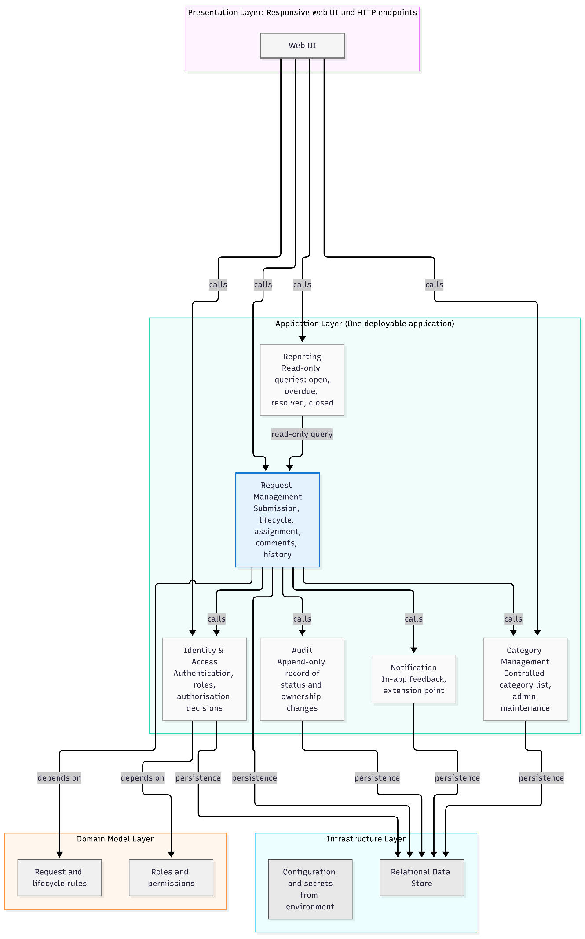
4.3 Request lifecycle (the rule enforced in one place, ASR-2)
M1 names the transitions Submitted → Acknowledged → In Progress → Resolved (M1 §2.1) and FR-006/FR-013 add rejected and closed outcomes. The exact transition table below is a proposal to confirm with the team, because M1 does not define it fully.
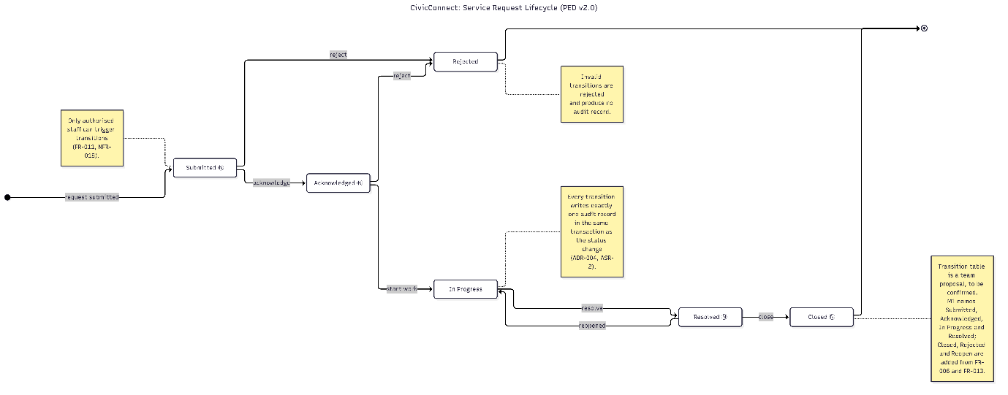
4.4 Physical deployment view (deliberately separate from the logical view)
The logical view above says how the code is organised. This view says where it runs. They are different things: several logical modules share one physical process (Kruchten, 1995; Brown, n.d.).
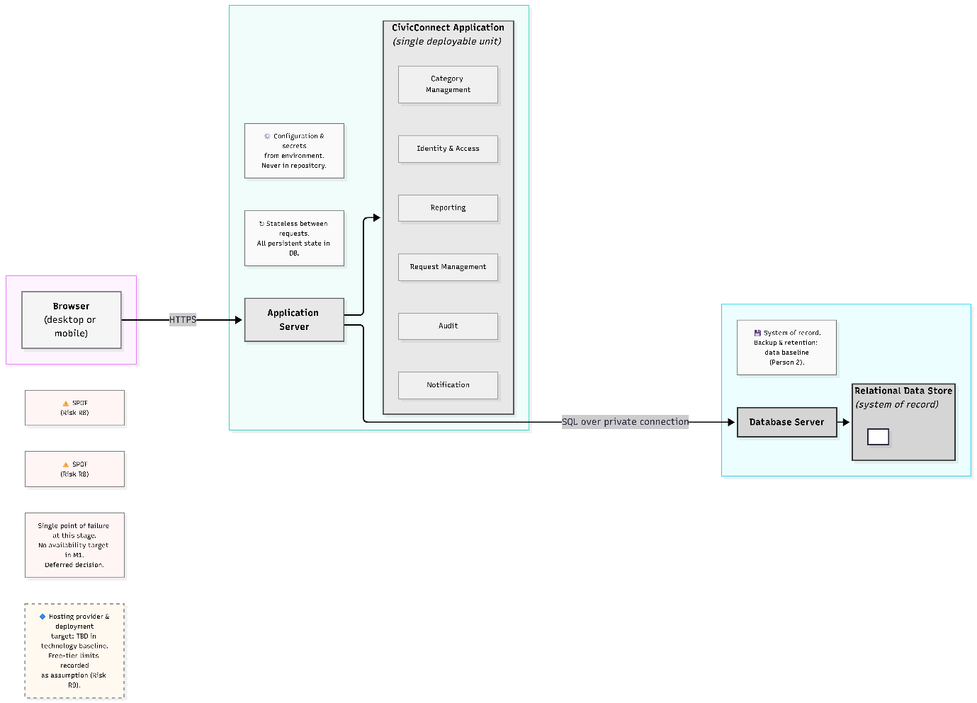
- Three physical tiers: browser, application server, database. One deployable application.
- Deployment target, hosting provider and exact technologies: not decided here. They belong to the technology baseline (Person 2) and the deployment compatibility section, and must be plausible against M1's free-tier assumption. The architecture is written to be technology-neutral so the A1 candidate stacks remain valid options.
- Known implications recorded: configuration and secrets come from the environment and are never committed; the database holds all persistent state, so the application tier stays stateless between requests; one application instance and one database are single points of failure at this stage (Risk R8).

5. Architecture Decision Records
Format adapted from Nygard (2011). Status values: Proposed / Accepted / Superseded. All four are Proposed until the team signs the baseline.
ADR-001: Modular monolith as the architectural style
- Status: Proposed | Date: [date] | Owner: Person 1
- Context: Three-person team, fixed milestones, free-tier cost assumption, and five ASRs dominated by security, atomic audit and modifiability (Section 2). Three M1 features are deferred and must be addable later.
- Decision: One deployable application structured as six business modules with enforced boundaries and internal layering (Section 4).
- Alternatives considered: A layered monolith (little protection against sprawl), C microservices (breaks atomic change-plus-audit, disproportionate operational load), D BaaS-first (rules held in vendor configuration, free-tier and lock-in risk). Scores in Section 3.2.
- Consequences: (+) transactions span modules, simple deployment, cheap to run, easy to test in-process. (−) modules share one deployment and one failure domain; boundaries depend on team discipline and code review rather than the network, so violations must be caught in PR review; scaling is whole-application.
- Evidence: Bass, Clements and Kazman (2021); Richards and Ford (2020); Fowler (2015); Newman (2021). [Week 2 teaching reference: insert lecture/slide.] [A2 reference if architecture/SCM research informed this: insert section.]
- If changed, affects: Section 4 diagrams, RTM module column, deployment assumptions, ADR-002 to ADR-004, risks R5 to R8.
- Revisit trigger: measured load breaching ASR-5, or an expected-volume figure that a single instance cannot serve.
ADR-002: Module decomposition and dependency rules
- Status: Proposed | Date: 30/9/2026 | Owner: Person 1
- Context: ASR-4 requires change isolation; NFR-023 requires well-defined component responsibilities.
- Decision: The six modules and four dependency rules in Section 4.1. Boundaries follow business capabilities rather than technical layers (Evans, 2004).
- Alternatives considered: Two or three coarse modules (less overhead, less isolation); one module per M1 requirement group (too granular for the team size).
- Consequences: (+) clear ownership and testability. (−) extra interfaces to maintain; Audit and Notification are small modules that may look over-split. Justified by their independent reasons to change (audit rules vs. future channels).
- Enforcement: folder/package structure mirrors modules; PR review checklist includes "no cross-module internals"; [optional: automated dependency check if the stack supports it, recorded once Person 2 confirms the stack].
- Evidence: Martin (2017); Evans (2004); Bass, Clements and Kazman (2021).
- If changed, affects: repository structure, README module map, RTM allocation column.
ADR-003: Central, deny-by-default server-side authorisation
- Status: Proposed | Date: 30/9/2026 | Owner: Person 1
- Context: ASR-1. Request data may be sensitive and must be protected under POPIA (Republic of South Africa, 2013). M1 selected role-based access control following the NIST/ANSI model (Sandhu, Ferraiolo and Kuhn, 2000; ANSI/INCITS, 2004). Broken access control is the most common web application weakness in the OWASP ranking (OWASP, 2021).
- Decision: Identity & Access is the only module that makes access decisions. Every protected operation passes through it on the server, and the default outcome is deny. UI hiding of controls is a usability aid only, never the control itself. Role checks are combined with ownership checks (e.g. a requester sees only their own requests).
- Alternatives considered: Per-feature ad hoc checks (inconsistent, hard to audit); UI-only restrictions (not a control at all); delegating entirely to a vendor policy layer (see ADR-001, option D).
- Consequences: (+) one place to review and test; matches the AC-017 to AC-019 acceptance evidence. (−) every new feature must route through it, and a bug there has wide impact, so it needs the strongest automated tests.
- Evidence: Sandhu, Ferraiolo and Kuhn (2000); ANSI/INCITS (2004); OWASP (2021); Republic of South Africa (2013), section 19 [verify section wording against the Act before submission].
- If changed, affects: NFR-017 to NFR-019 traceability, Identity & Access interface, every endpoint's test plan.
ADR-004: Lifecycle rules and audit record written in one transaction
- Status: Proposed | Date: 30/9/2026 | Owner: Person 1 (co-owned with Person 2 for the data aspects)
- Context: ASR-2 and ASR-3. Management needs reliable accountability data (M1 §1.3); the audit trail must not be able to drift from the actual state of a request.
- Decision: Status and ownership changes are applied only through Request Management's lifecycle rules (Section 4.3). The audit entry is written in the same database transaction as the change, so both succeed or neither does. Audit records are append-only: no edit or delete path is exposed.
- Alternatives considered: Audit written afterwards by a separate process or event (can lose entries on failure); database triggers only (logic hidden from code review, harder to test); no separate audit store, derived from current state only (loses history).
- Consequences: (+) audit integrity is structural, not procedural. (−) audit writes add a small cost to each change (acceptable against ASR-5); audit tables grow over time, so retention is an open data decision.
- Evidence: Bass, Clements and Kazman (2021); Fowler (2002) on domain logic organisation; [A2 persistence/transaction research section if used: insert reference].
- If changed, affects: data model (Person 2), NFR-020 traceability, Reporting (FR-014).
ADR candidate for the team to decide ownership of (overlaps Person 3's design decisions): in-app notification mechanism for FR-006, and how the extension point for deferred channels is shaped. Record as ADR-005 once Person 3's design patterns are final.

6. Risk Register additions (architecture-related)
Continues the M1 register (R1 to R4) using the same columns. Person 3 owns the register; these are submitted for merge.
ID | Risk | Probability | Impact | Priority | Mitigation | Owner | Contingency | Status
R5 | Module boundaries erode inside the monolith (shortcuts across modules) | Medium | Medium | Medium | ADR-002 rules, PR checklist item, folder structure mirrors modules | Architecture lead | Refactoring task scheduled before the next milestone | Open
R6 | Access control bypassed through an endpoint that skips the central check | Medium | High | High | ADR-003; authorisation tests per endpoint; review checklist | Team | Security review and fix before release; log as change | Open
R7 | Architecture over-engineered relative to the team's capacity | Low | Medium | Low | Proportionality principle (ADR-001); revisit if a module has no independent reason to exist | Architecture lead | Merge modules via a controlled ADR change | Open
R8 | Single application instance and single database are single points of failure; no availability target defined | Medium | Medium | Medium | Persist-then-confirm (ASR-3); backup approach decided by Person 2; record availability as a deferred decision | Team | Restore from backup; document recovery steps | Open
R9 | Free-tier hosting limits conflict with ASR-5 or ASR-3 | Medium | Medium | Medium | Record limits as a dependency assumption (M1 Cost constraint); measure early | Person 2 | Move to a paid tier or simplify reporting queries | Open

7. RTM: architecture columns (for M2 merge)
Adds the architecture columns to the M1 RTM. The M1 RTM grouped requirements by stakeholder; the per-requirement rows below are a finer-grained view suitable for tracing. Data, design, technology, implementation and verification columns are for Persons 2 and 3; use the controlled status "Planned" where evidence does not yet exist, and do not back-fill evidence that has not happened.
Req ID | ASR link | Architecture module(s) | ADR / risk ref
FR-001 | ASR-3 | Request Management; Category Management (validation) | ADR-001, ADR-004
FR-002 | ASR-4 | Category Management | ADR-002
FR-003 | ASR-3 | Request Management | ADR-004
FR-004 | ASR-1 | Request Management; Identity & Access | ADR-003
FR-005 | ASR-1, ASR-2 | Request Management; Audit | ADR-003, ADR-004
FR-006 | ASR-4 | Notification | ADR-002 (ADR-005 candidate)
FR-007 | ASR-1 | Request Management; Identity & Access | ADR-003, R6
FR-008 | ASR-5 | Request Management (query) | ADR-002
FR-009 | ASR-1 | Request Management; Identity & Access | ADR-003
FR-010 | ASR-1, ASR-2 | Request Management; Identity & Access; Audit | ADR-003, ADR-004
FR-011 | ASR-2 | Request Management (lifecycle); Audit | ADR-004
FR-012 | ASR-1, ASR-2 | Request Management; Audit | ADR-003, ADR-004
FR-013 | ASR-2 | Request Management (lifecycle); Audit | ADR-004
FR-014 | ASR-1, ASR-2 | Reporting; Audit | ADR-003, ADR-004
FR-015 | ASR-5 | Reporting | CR-002
FR-016 | ASR-5 | Reporting | ADR-002
NFR-017 | ASR-1 | Identity & Access | ADR-003
NFR-018 | ASR-1 | Identity & Access | ADR-003
NFR-019 | ASR-1 | Identity & Access; Request Management | ADR-003, R6
NFR-020 | ASR-2 | Audit | ADR-004
NFR-021 | none (not an ASR) | Presentation layer | n/a
NFR-022 | ASR-3 | Infrastructure (data store) | ADR-004, R8
NFR-023 | ASR-4 | All modules | ADR-001, ADR-002, R5
NFR-024 | ASR-5 | Reporting; Request Management (query) | CR-001, R9
Suggested end-to-end trace (required by the M2 brief, Section 9)
Pick one path the team will actually implement first. A strong candidate because it touches every ASR decision:
FR-011 (update status through controlled transitions) → ASR-2 → Request Management lifecycle rules + Audit → audit entity and transaction (Person 2) → state/transition design decision (Person 3) → technology and ADR-004 → [branch/class/endpoint] → [test showing an invalid transition is rejected and a valid one writes one audit record].
Fill the bracketed items only with real repository evidence. The brief explicitly penalises decisions with no visible application translation once implementation has begun.

8. Forward Engineering Considerations (updates) and deferred decisions
M1's six considerations are retained. Updates from architecture:
Consideration | Update in v2.0
Security | Now concrete: ADR-003. Still missing: exact authentication mechanism and session handling (Person 2 technology decision).
Scalability | Single instance assumed (ADR-001). Still missing: expected user volumes. Deferred until a volume estimate exists.
Testability | Modules testable in isolation (ASR-4). Test environment definition still pending.
Deployment | Logical vs physical views separated (Section 4.4). Hosting platform deferred to Person 2's deployment section.
Data recovery | Persist-then-confirm adopted (ASR-3). Retention and backup frequency remain open (Person 2).
Observability | Still deferred. No ADR in M2.
Deliberately deferred (brief asks for at least one to be explained at the defence):
Deferred decision | Why deferred | Evidence needed before deciding
Horizontal scaling / separating Reporting into its own deployable | No user-volume or load data; complexity unjustified now | Measured response times against ASR-5 under expected load
Availability target and redundancy | M1 defines no availability requirement | Stakeholder confirmation of acceptable downtime
Notification channels beyond in-app (email/SMS) | Out of M1 scope, cost decision pending | Cost and licensing evidence; approved change request

9. M2 Architecture, Technology & Initial Design Baseline (Person 1 sign-off section)
Person 1 owns baseline sign-off; contents from Persons 2 and 3 are merged here.
Baseline identifier: CivicConnect M2 Baseline, PED v2.0, dated [date].
Included in the baseline:
- M1 requirements baseline as amended by CR-001 to CR-003 (once approved)
- ASR-1 to ASR-5 (Section 2)
- Architecture decision and diagrams (Sections 3 and 4); ADR-001 to ADR-004
- [Person 2: data model, persistence decisions, technology stack ADRs]
- [Person 3: two design-pattern decisions, interface decisions, repository structure]
- RTM v2.0 and Risk Register entries R1 to R9
Open or deferred (separately identified): see Section 8; plus [Person 2/3 open items].
Change control after baseline: any material change to an ADR follows the controlled process: new ADR marked as superseding the old one, reason recorded, affected RTM rows and risks updated, two-reviewer PR.
Team member | M2 role | Signature | Date
Riegardt Weich | Architecture & Quality Drivers
[Person 2] | Data, Persistence & Technology
[Person 3] | Design, Development & Governance

10. References
All in-text citations above use (Author, year). Add these to the PED Sources section alongside the M1 sources, which remain unchanged. The M1 entries already in the PED and reused here are: American National Standards Institute/INCITS (2004), ISO/IEC (2011), Republic of South Africa (2013), Sandhu, Ferraiolo and Kuhn (2000), Bass, Weber and Zhu (2015).
Bass, L., Clements, P. and Kazman, R. (2021) Software architecture in practice. 4th edn. Boston: Addison-Wesley.
Brown, S. (n.d.) The C4 model for visualising software architecture. Available at: https://c4model.com (Accessed: [date]).
Evans, E. (2004) Domain-driven design: tackling complexity in the heart of software. Boston: Addison-Wesley.
Fowler, M. (2002) Patterns of enterprise application architecture. Boston: Addison-Wesley.
Fowler, M. (2015) 'MonolithFirst', martinfowler.com, 3 June. Available at: https://martinfowler.com/bliki/MonolithFirst.html (Accessed: [date]).
Kruchten, P. (1995) 'The 4+1 view model of architecture', IEEE Software, 12(6), pp. 42–50.
Martin, R.C. (2017) Clean architecture: a craftsman's guide to software structure and design. Upper Saddle River, NJ: Prentice Hall.
Newman, S. (2021) Building microservices: designing fine-grained systems. 2nd edn. Sebastopol, CA: O'Reilly Media.
Nygard, M. (2011) 'Documenting architecture decisions', Cognitect Blog, 15 November. Available at: https://www.cognitect.com/blog/2011/11/15/documenting-architecture-decisions (Accessed: [date]).
OWASP Foundation (2021) OWASP Top 10:2021, A01 Broken Access Control. Available at: https://owasp.org/Top10/A01_2021-Broken_Access_Control/ (Accessed: [date]).
Richards, M. and Ford, N. (2020) Fundamentals of software architecture: an engineering approach. Sebastopol, CA: O'Reilly Media.
Verification note: these are real, standard sources, but they were suggested with AI assistance. Before submission, open each one and confirm that it actually supports the sentence it is attached to, check edition and publisher details against your copy or library record, fill in your own access dates, and record this in the AI Usage Register (Person 3 maintains it). The M2 brief requires claims first obtained through AI to be checked against authoritative sources.

